HALL TICKET NO | 0425046043
NAME | VEPPAREDDY GARI LAVA KUMAR REDDY

AREA CHART :
- option onto Open your worksheet (your Area Chart is already open).
- Look at the left sidebar where Pages, Filters, Marks appear.
- At the top-left panel, find the tabs Data and Analytics.
- Click Analytics.
- The Analytics panel opens with options like Forecast, Trend Line, Reference Line, Average Line.
- Drag the required analytics your chart and drop it.
OUTPUT:
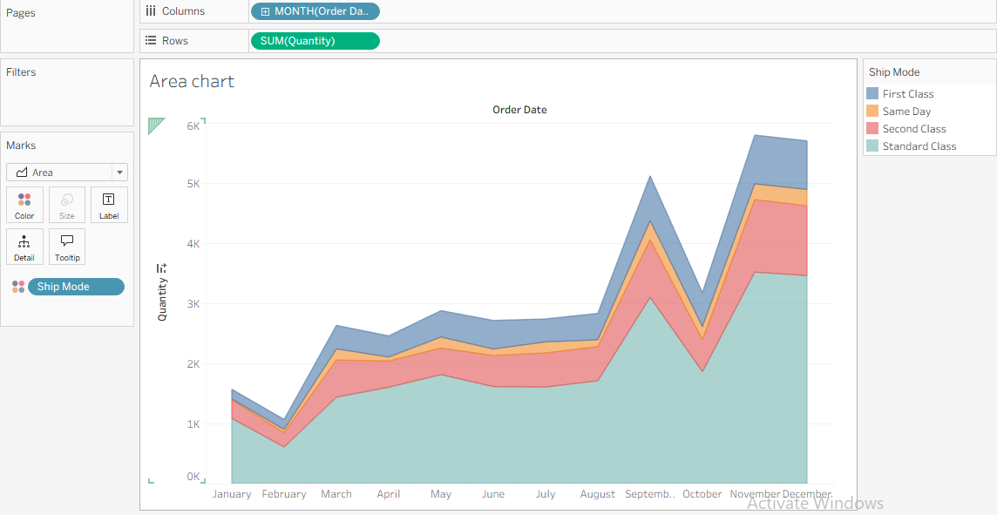

BAR CHART :
- Open a new Worksheet in Tableau.
- Drag Region → Rows shelf
  - This displays regions on the chart.
- Drag Sales → Rows shelf
  - Tableau creates SUM(Sales) automatically.
- Set Marks type to Bar
  - In the Marks card → select Bar (or keep Automatic if already bar).
- Drag Ship Mode → Color (Marks card)
  - This creates stacked color sections inside the bar.
- Drag Region → Filters shelf
  - Select West → click OK to show only West region.
- Format and adjust chart
  - Edit title to Bar chart.
  - Show color legend and resize the bar if needed.

OUTPUT
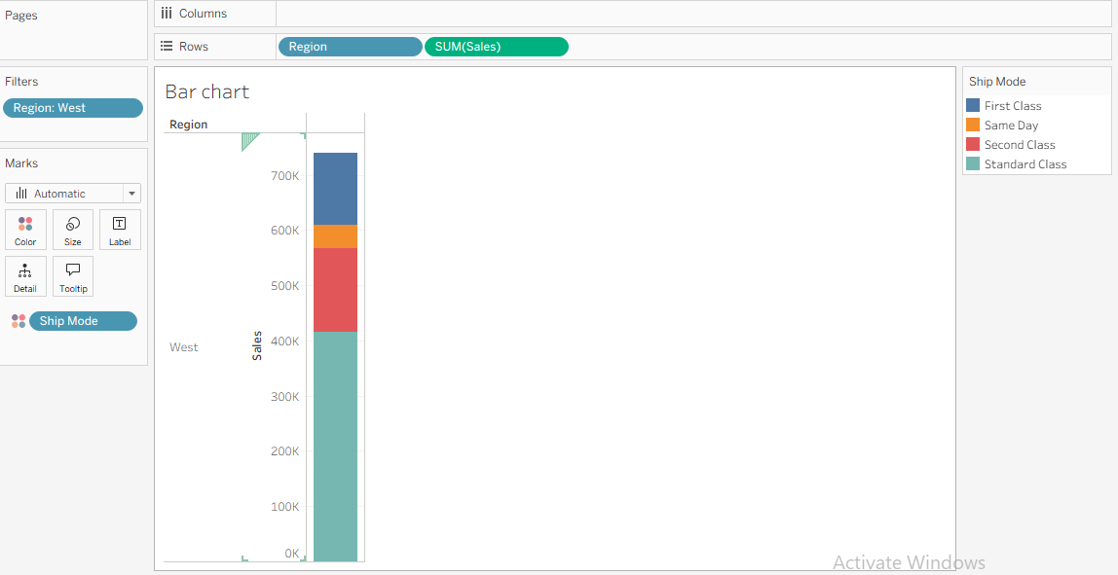

BOX PLOT CHART :
- Open a new Worksheet in Tableau.
- Drag Discount → Columns shelf to create the horizontal axis.
- Drag Segment → Rows shelf to display categories.
- Drag Region → Rows shelf beside Segment for regional comparison.
- Open Show Me → Select Box-and-Whisker Plot to generate the box plot.
- Format the chart by adjusting labels, title, and tooltip for better presentation.

OUTPUT :

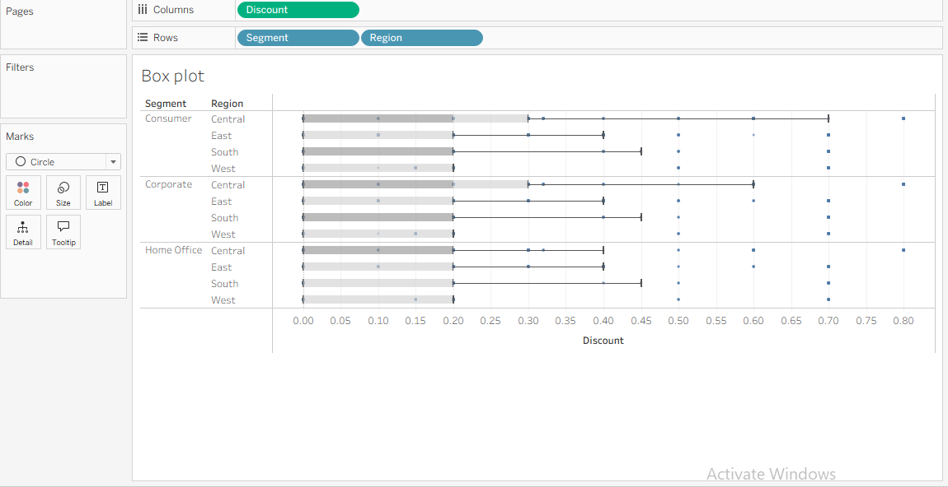

GANTT CHART :
- Connect Data → Open Tableau and connect to the dataset.
- Add Columns → Drag Order Date to Columns and change it to Week.
- Add Rows → Drag Sub-Category and Ship Mode into Rows.
- Create Gantt View → In Marks, select Gantt Bar chart type.
- Apply Measures → Drag Order Until Ship to Size and Ship Mode to Color.
- Format Dashboard → Adjust colors, labels, spacing, and fit the chart for clear visualization.

OUTPUT :

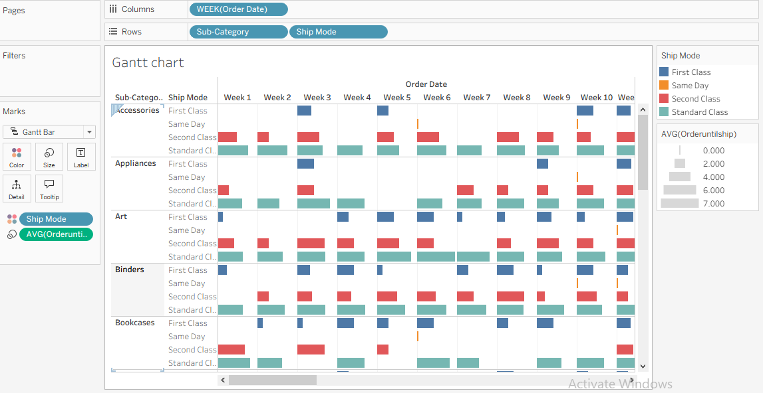

HEAT MAP :
- Connect Data → Open Tableau and load the dataset.
- Create Columns → Drag Segment into the Columns shelf.
- Create Rows → Drag Region and Sub-Category into the Rows shelf.
- Build Heat Map → Select Show Me → Heat Map or keep Marks → Automatic/Square.
- Apply Measures → Drag Profit to Color and Sales to Size.
- Add Filter & Format → Drag Region to Filters, adjust color scale, labels, and chart size.

OUTPUT :

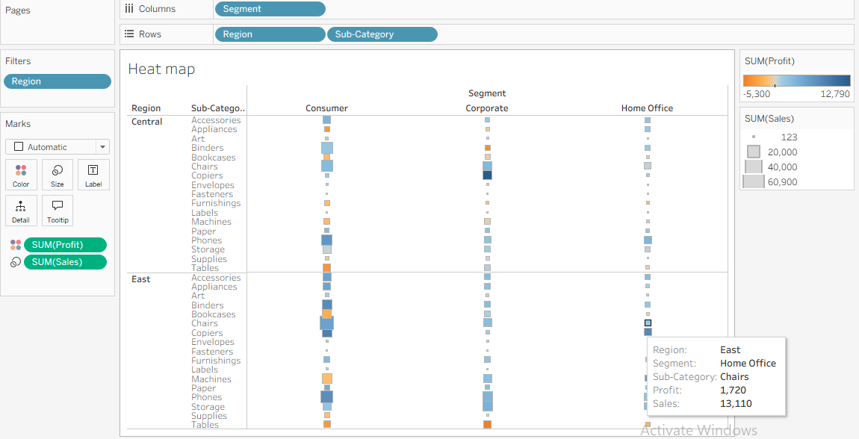

HISTOGRAM CHART :
- Create Bins
  - Right-click Quantity → Create → Bins
  - Choose bin size (e.g., 1) → OK
- Build Histogram
  - Drag Quantity (bin) to Columns
  - Drag Quantity to Rows and change aggregation to CNT(Quantity)
- Change Mark Type
  - In the Marks card, select Bar (or keep Automatic if it shows bars).
- Add Segment Colors
  - Drag Segment to Color on the Marks card.
- Show Values
  - Drag SUM(Quantity) to Label
  - Turn on Show Mark Labels.
- Format the Chart
  - Rename the title to Histogram
  - Adjust colors, labels, and axis formatting as needed.
OUPUT :
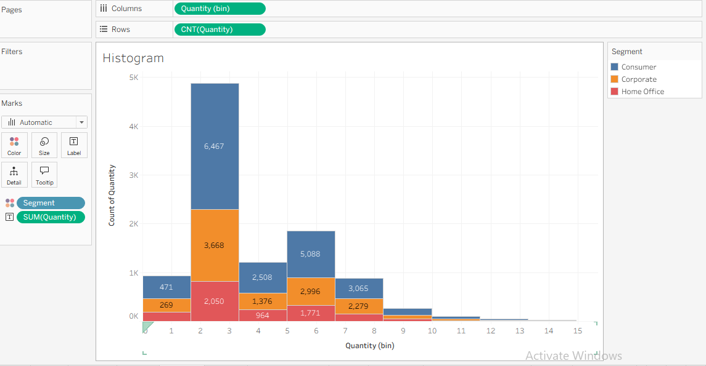
LINE CHART :
1. Synchronize the Axis Scales
- The issue: Sales (orange) and Profit (blue) share a single axis, which flattens the profit line at the bottom.
- The fix: Drag Measure Values out of Rows.
- Action: Place SUM(Sales) and SUM(Profit) directly next to each other in the Rows shelf to create a dual-axis chart, then right-click the right axis and select Synchronize Axis (or leave them independent if you want to see profit trends clearer).
2. Format Axis Labels and Suffixes
- The issue: The Y-axis is simply labeled "Value," which is generic.
- The fix: Right-click the Y-axis and select Edit Axis.
- Action: Change the title to "Amount (USD)" or your specific currency, and format the numbers to include currency symbols ($) alongside the existing "K" shorthand.
3. Simplify the Color Palette
- The issue: The legend lists four different colors/shades for actuals vs. estimates, cluttering the view.
- The fix: Use two distinct primary colors (e.g., dark blue for Sales, dark green for Profit).
- Action: Use solid lines for "Actual" data and dashed lines or lighter opacity formatting for the "Estimate" forecast periods instead of entirely separate color entries.
4. Clean Up the Sheet Titles
- The issue: The chart header literally says "Line chart," which adds no value to the end-user.
- The fix: Double-click the title text box.
- Action: Rename it to something descriptive and action-oriented, such as "Sales & Profit Forecast through 2027."
5. Remove Gridlines and Zero Lines
- The issue: Horizontal gridlines compete with the trend lines, distracting the eye.
- The fix: Right-click anywhere on the chart background and select Format.
- Action: Go to the Lines tab and set Grid Lines and Zero Lines to "None" for a cleaner, modern look.
6. Relocate or Customize the Legend
- The issue: The legend on the right takes up valuable horizontal real estate, compressing the timeline.
- The fix: Move or integrate the legend.
- Action: Drag the legend card below the chart, or completely hide it and use color-coded text directly within your new descriptive chart title.

OUTPUT
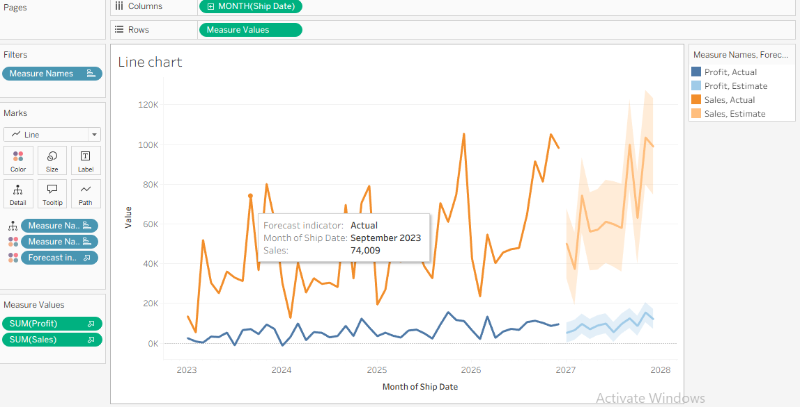

PACKED BUBBLE CHART

- Open a New Worksheet
  - Go to a new sheet and select Show Me → Packed Bubbles.
- Add Bubble Size
  - Drag Sales to Size on the Marks card.
- Add Bubble Color
  - Drag Profit to Color to create the color gradient.
- Add Labels
  - Drag Category and Region to Label to display names inside bubbles.
- Add Detail
  - Drag Region (or another dimension if needed) to Detail for separate bubbles by category and region.
- Format the Chart
  - Edit the title to Packed Bubble Chart.
  - Adjust label alignment, bubble size, and color legend for better readability.
OUTPUT

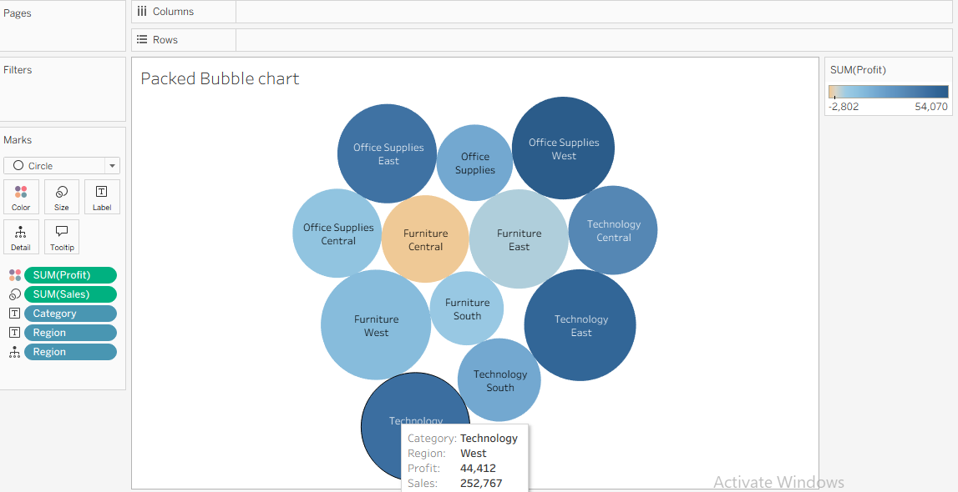
PIE CHART
- Open a New Worksheet
  - From the Marks card, select Pie as the chart type.
- Add Category Segments
  - Drag Category to Color.
- Define Slice Size
  - Drag Profit to Angle to size each pie slice by profit.
- Adjust Pie Size
  - Drag Profit to Size and increase the slider for a larger pie chart.
- Show Labels
  - Drag Category to Label to display category names on the slices.
- Format the Chart
  - Rename the title to Pie Chart and adjust colors/labels for clarity.
OUTPUT
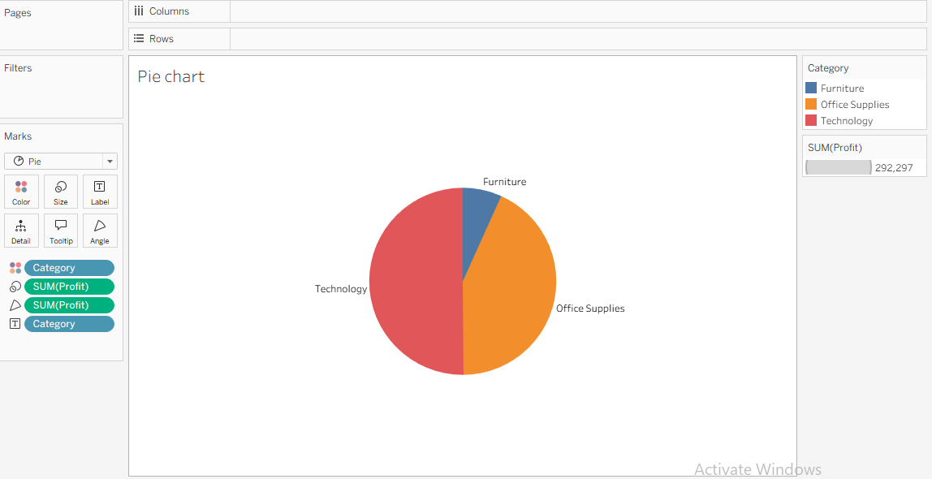

SCATTER CHART
Step 1: Open a New Worksheet
- Create a new worksheet and rename it Scatter Chart.
Step 2: Add Measures to Axes
- Drag Sales to Columns.
- Drag Profit to Rows.
Step 3: Create Individual Marks
- Drag Category to Color.
- Drag Region to Detail on the Marks card.
Step 4: Set Mark Type
- From the Marks dropdown, select Circle (or keep Automatic if circles appear).
Step 5: Format the Scatter Plot
- Adjust the Size slider if needed.
- Ensure each point represents a Region within a Category.
Step 6: Add Trend Lines
- Go to Analytics pane.
- Drag Trend Line → drop on Per Color to create separate trend lines for each category.
Step 7: Final Formatting
- Add the title Scatter Chart.
- Show the Category color legend.
- Format axis labels (Sales and Profit) and gridlines as required.
OUTPUT
- 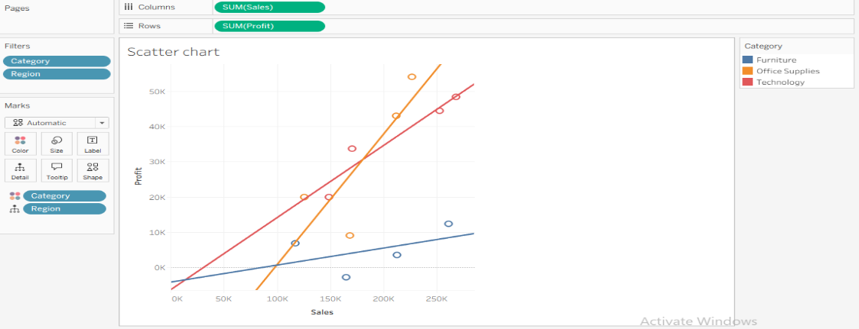
Text Table with percentages
Step 1: Create a New Worksheet
- Open a new sheet and rename it Text Table with Percentages.
Step 2: Build the Table Structure
- Drag YEAR(Order Date) to Columns.
- Drag Region and Sub-Category to Rows.
Step 3: Add the Measure
- Drag Sales to Text on the Marks card.
- A text table (crosstab) is created.
Step 4: Convert Values to Percentages
- Right-click SUM(Sales) on the Marks card.
- Select Quick Table Calculation → Percent of Total.
Step 5: Configure the Calculation
- Right-click the field again → Edit Table Calculation.
- Set Compute Using to the required direction (e.g., Table Across for yearly percentages).
Step 6: Format the Percentage Table
- Right-click any value → Format.
- Change Numbers to Percentage and adjust decimal places.
- Edit the title to Text Table with Percentages.
OUTPUT
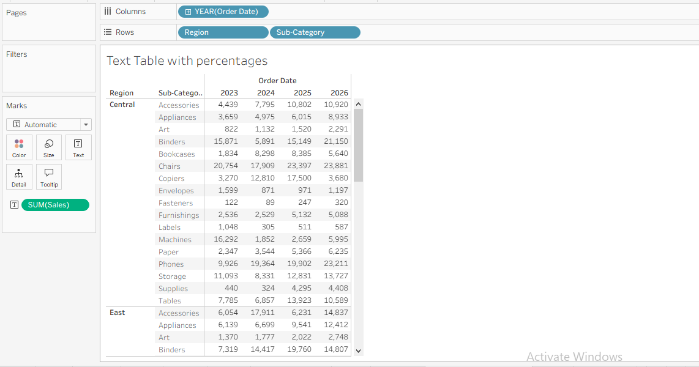

Tree map
Step 1: Create a New Worksheet
- Open a new sheet and rename it Tree Map.
Step 2: Select Treemap
- Click Show Me → choose Treemap.
Step 3: Define Rectangle Size
- Drag Sales to Size on the Marks card.
Step 4: Add Color and Labels
- Drag Profit to Color.
- Drag Sub-Category to Label.
Step 5: Format the Visualization
- Adjust colors, labels, and tooltip settings.
- Add the title Tree Map.

OUTPUT
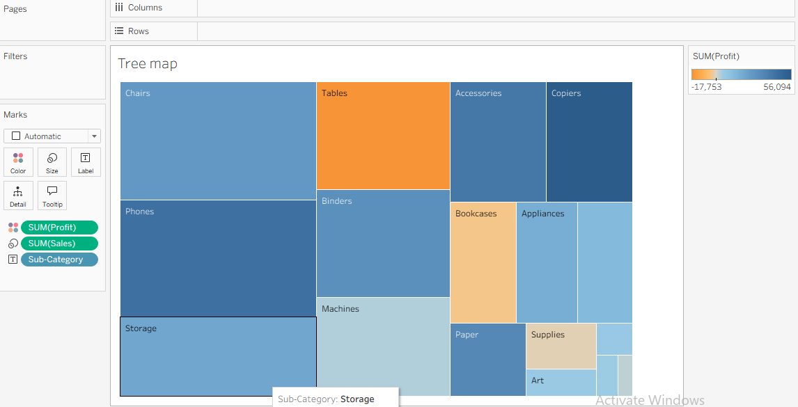

DOUNT CHART:
- Color Slices: Drag Region to Color on the first card.
- Label Slices: Drag Region and Sales to the Label shelf.
- Set Angles: Drag Sales directly onto the Angle shelf.
- Select Center: Click the second SUM(Zero) Marks card.
- Center Value: Drag Sales to Label on this second card.
- Edit Text: Click Label, click (...), and type "Total Sales".

OUTPUT:

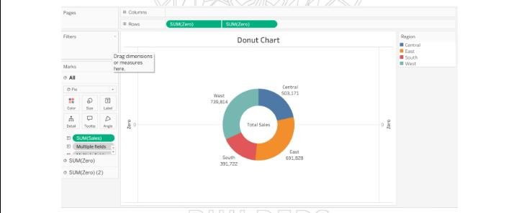

Map Chart

Step 1: Create the Map
- Double-click State/Province.
- Tableau automatically generates Longitude (generated) and Latitude (generated) to create the map.
Step 2: Add Geographic Detail
- Drag State/Province to Label to display state names on the map.
Step 3: Color by Measure
- Drag Sales to Color on the Marks card.
- A color gradient will represent sales performance by state.
Step 4: Display Sales Values
- Drag Sales to Label (or Text) to show sales figures on each state.
Step 5: Format the Map
- Add a title (Map Chart).
- Show the Sales color legend and adjust label formatting for readability.

OUTPUT:

